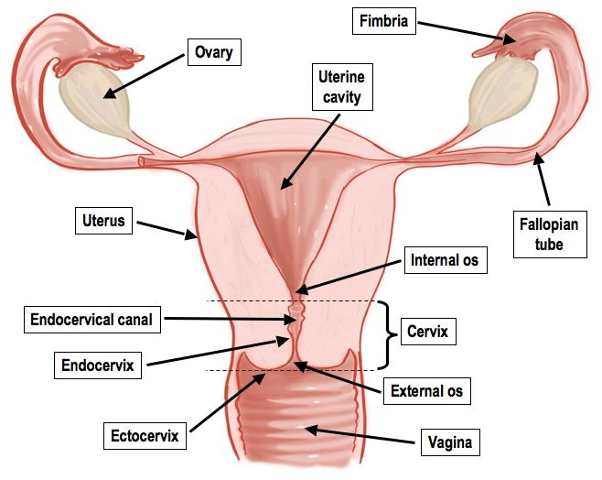

Name | Function/Importance
Vagina

Cervix

Uterus
(Womb)
Fallopian Tubes
(Oviduct)

Ovary

