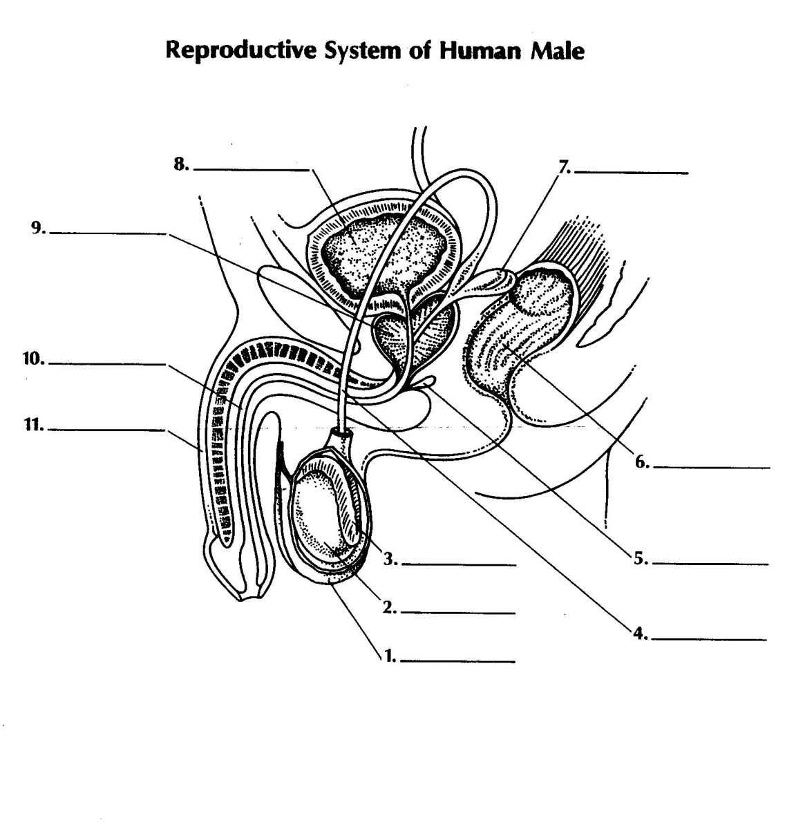
Name | Function | Importance
Penis

Testes
Scrotum
Epididymis
Vans Deferens
Ejaculatory Ducts
Urethra
Seminal Vesicles
Bulbourethral glands

