WORKSHEET – Lab Equipment

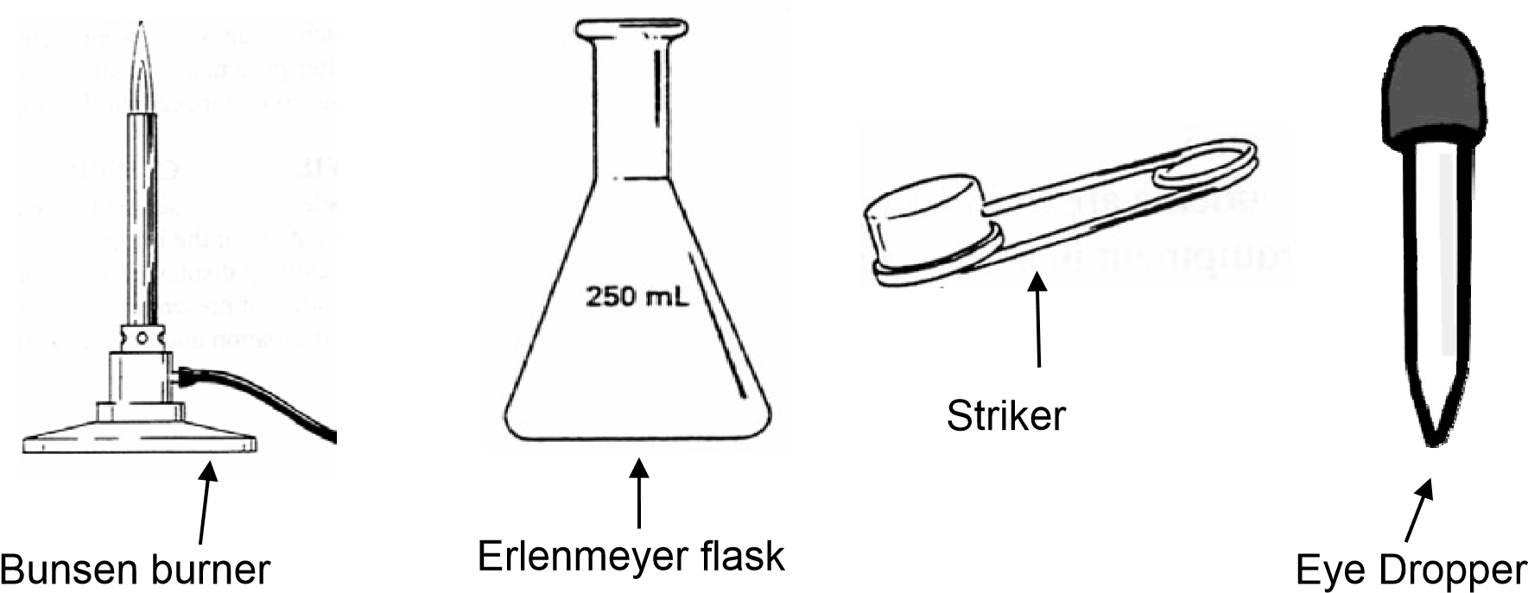
A number of items you will be using in the laboratory are shown below. Study this page and decide what the items may be used for, then, match the correct equipment pictured on this page
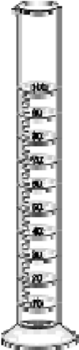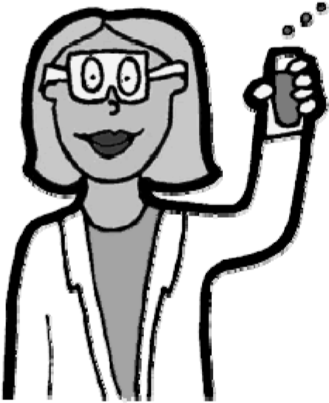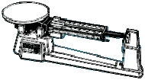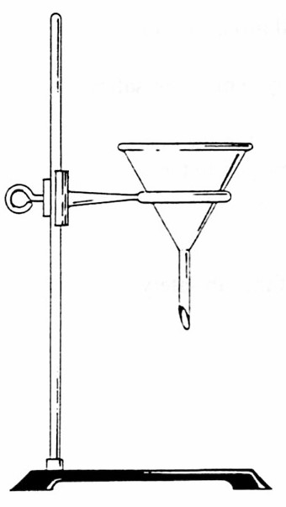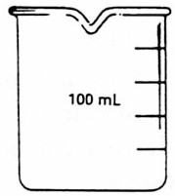
to the tasks asked for on the
other side of this paper.

Object Name | Used For
 | Used to pick up or hold hot objects
 | Protects the eyes from flying objects or chemical splashes
 | A wide-mouthed container used to transport, heat or store substances
 | A small glass container used to view chemical reactions or to heat small amounts of a substance
 | A device to measure the mass or “mass out” and object or substance.
 | Protects the scientist and the scientist’s clothes from hazardous or hot chemicals
 | Used to dispense a very small amount of a liquid
 | Used to light a Bunsen burner
 | Attaches to a lab stand and used to hold a variety of lab equipment
 | Used to measure volume very precisely
 | Used to hold a variety of lab equipment
 | Used to pour liquids into containers with small openings or to hold filter paper
 | Used to heat objects
 | A narrow-mouthed container used to transport, heat or store substances, often used when a stopper is required

